SWIMMER’S ITCH
There have been reports of swimmer’s itch at Norwegian Bay
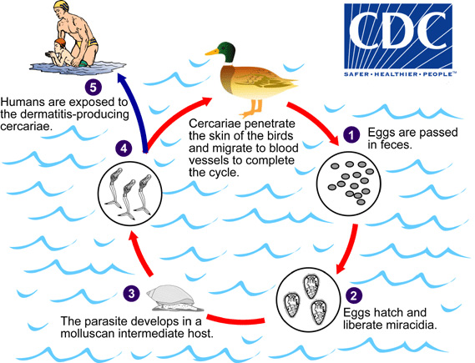
Symptoms of swimmer's itch may include:
- tingling, burning, or itching of the skin
- small reddish pimples
- small blisters
To reduce the likelihood of getting swimmer's itch:
- Do not swim in areas where swimmer's itch is a known problem or where signs have been posted warning of unsafe water.
- Do not swim near or wade in marshy areas where snails are commonly found.
- Towel dry or shower immediately after leaving the water.
- Do not attract birds (e.g., by feeding them) to areas where people are swimming.
- Report swimmers itch to your local health department.

